Mini Project #3

Project Description:

For the project A,I would like to create a fixed track of the bee’s movement,which is a special dancing called wager dancing for their communication of the position of the food.And I referred to the cos,sin function like this:

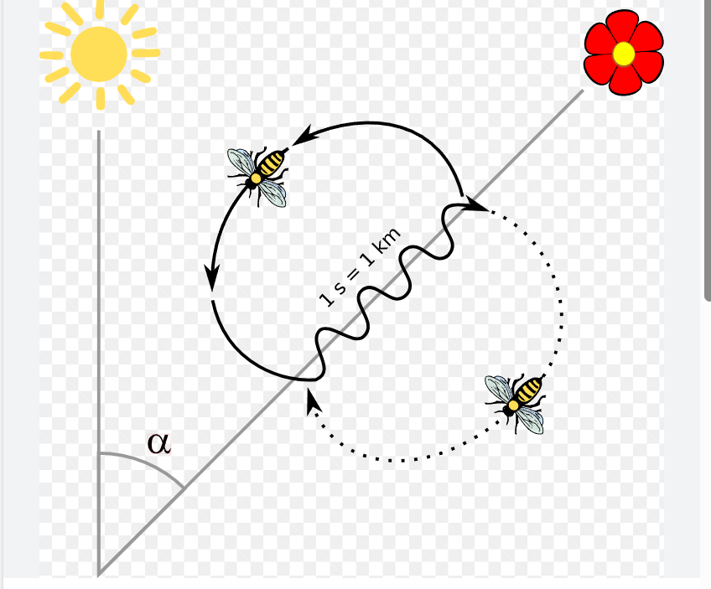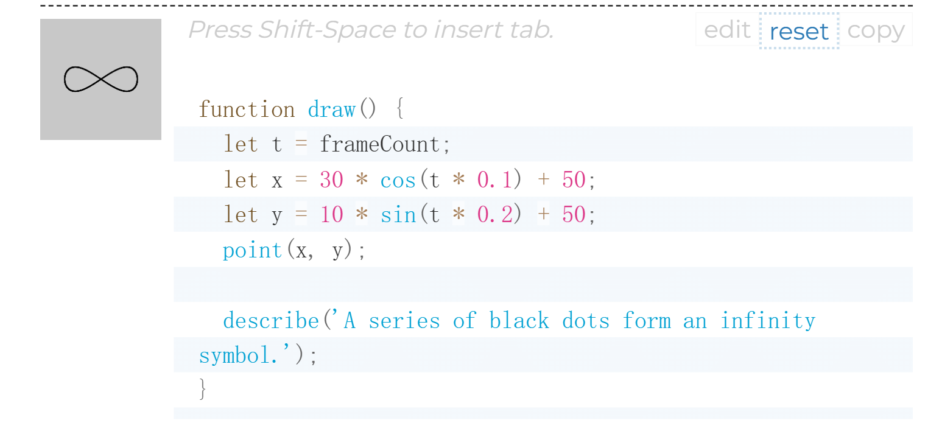

To replicate of the movement.The reason why I choose this one is that I need to completely restore of the nature status,the bee’s real living habit.Another movement I would like to dig into is the bounce of the two bees.I initially create two small bees which are looking forward the food ,they roam around and have the chance to collide with each other,but the difficulties are in the calculation of the distance of the two dots.And I ask assistant carrot for help,who suggest me using the function”dist”,which can calculate the position of the center of the patterns.From this movement ,it vividly showcases the bee’s nature movement,they look for food in a random track and may have crash with each other.However, that doesn’t reduce their enthusiasm for the food and consistently crash with each other and bounce around.What’s more,this process is also like their communication.When they don’t find food at that position, they will come back and share the failure during the finding,which shows a helping with each other.And that is the stepping--stone for their success.The coding is like this:”let d = dist(x1, y1, x, y);”for the calculation and the coding like this: drawbee1(x1, y1); if (d <= 60) {

y1Speed = y1Speed * -1.2;

x1Speed = x1Speed * -1.2;

ySpeed = ySpeed * -1.2;

xSpeed = xSpeed * -1.2;

}

Which used to describe the movement”bouncing around”We can see that I use the number”1.2”.Actually is modified by me many times.IF I only use 1,it doesn’t work as a real bouncing

“if (keyIsPressed == true && keyCode == LEFT_ARROW) {

x2 -= speed;

}

if (keyIsDown(RIGHT_ARROW)) {

x2 += speed;

}

if (keyIsDown(UP_ARROW)) {

y2 -= speed;

}

if (keyIsDown(DOWN_ARROW)) {

y2 += speed;

}

Is using for the control of the flower,which I use to add more interaction with the audience.Actually,it also shows the nature flower to some extent,which will flow in the wind randomly,And I just want to change this scenario to audience’s control.